Nonlinear analysis – Assignment 5

**Problem 1:**

The two first questions are answered by hand.

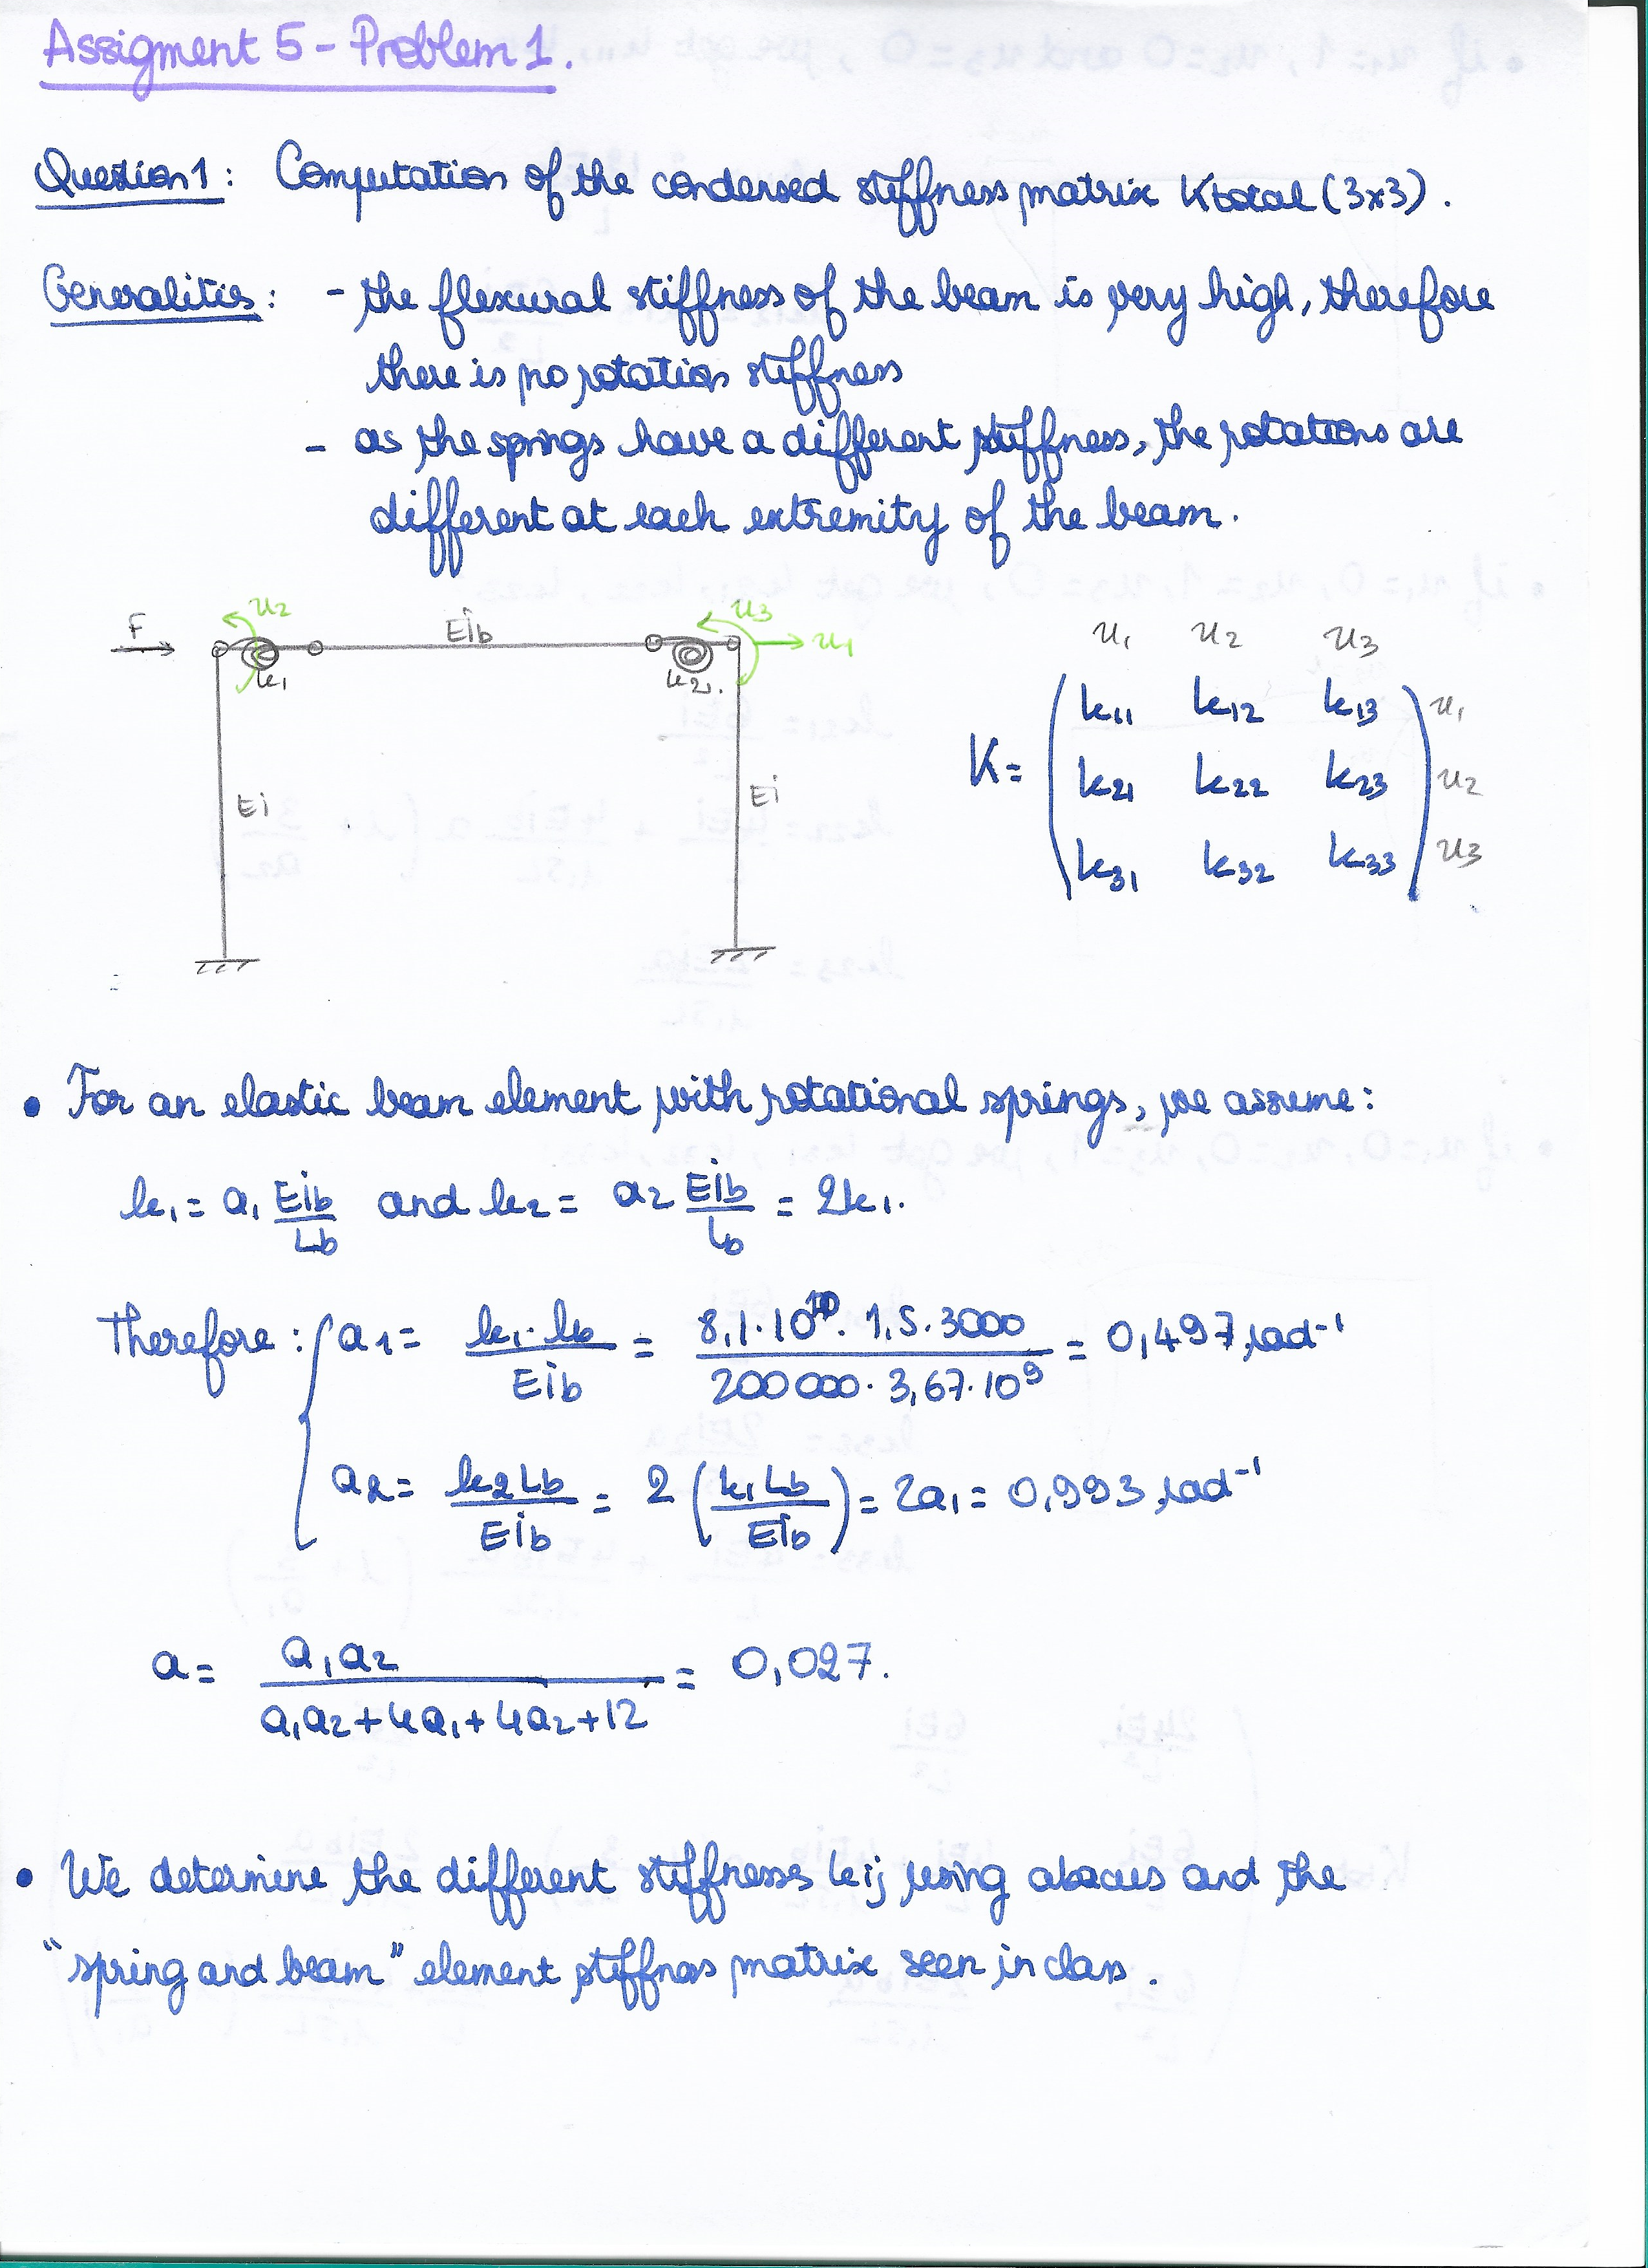

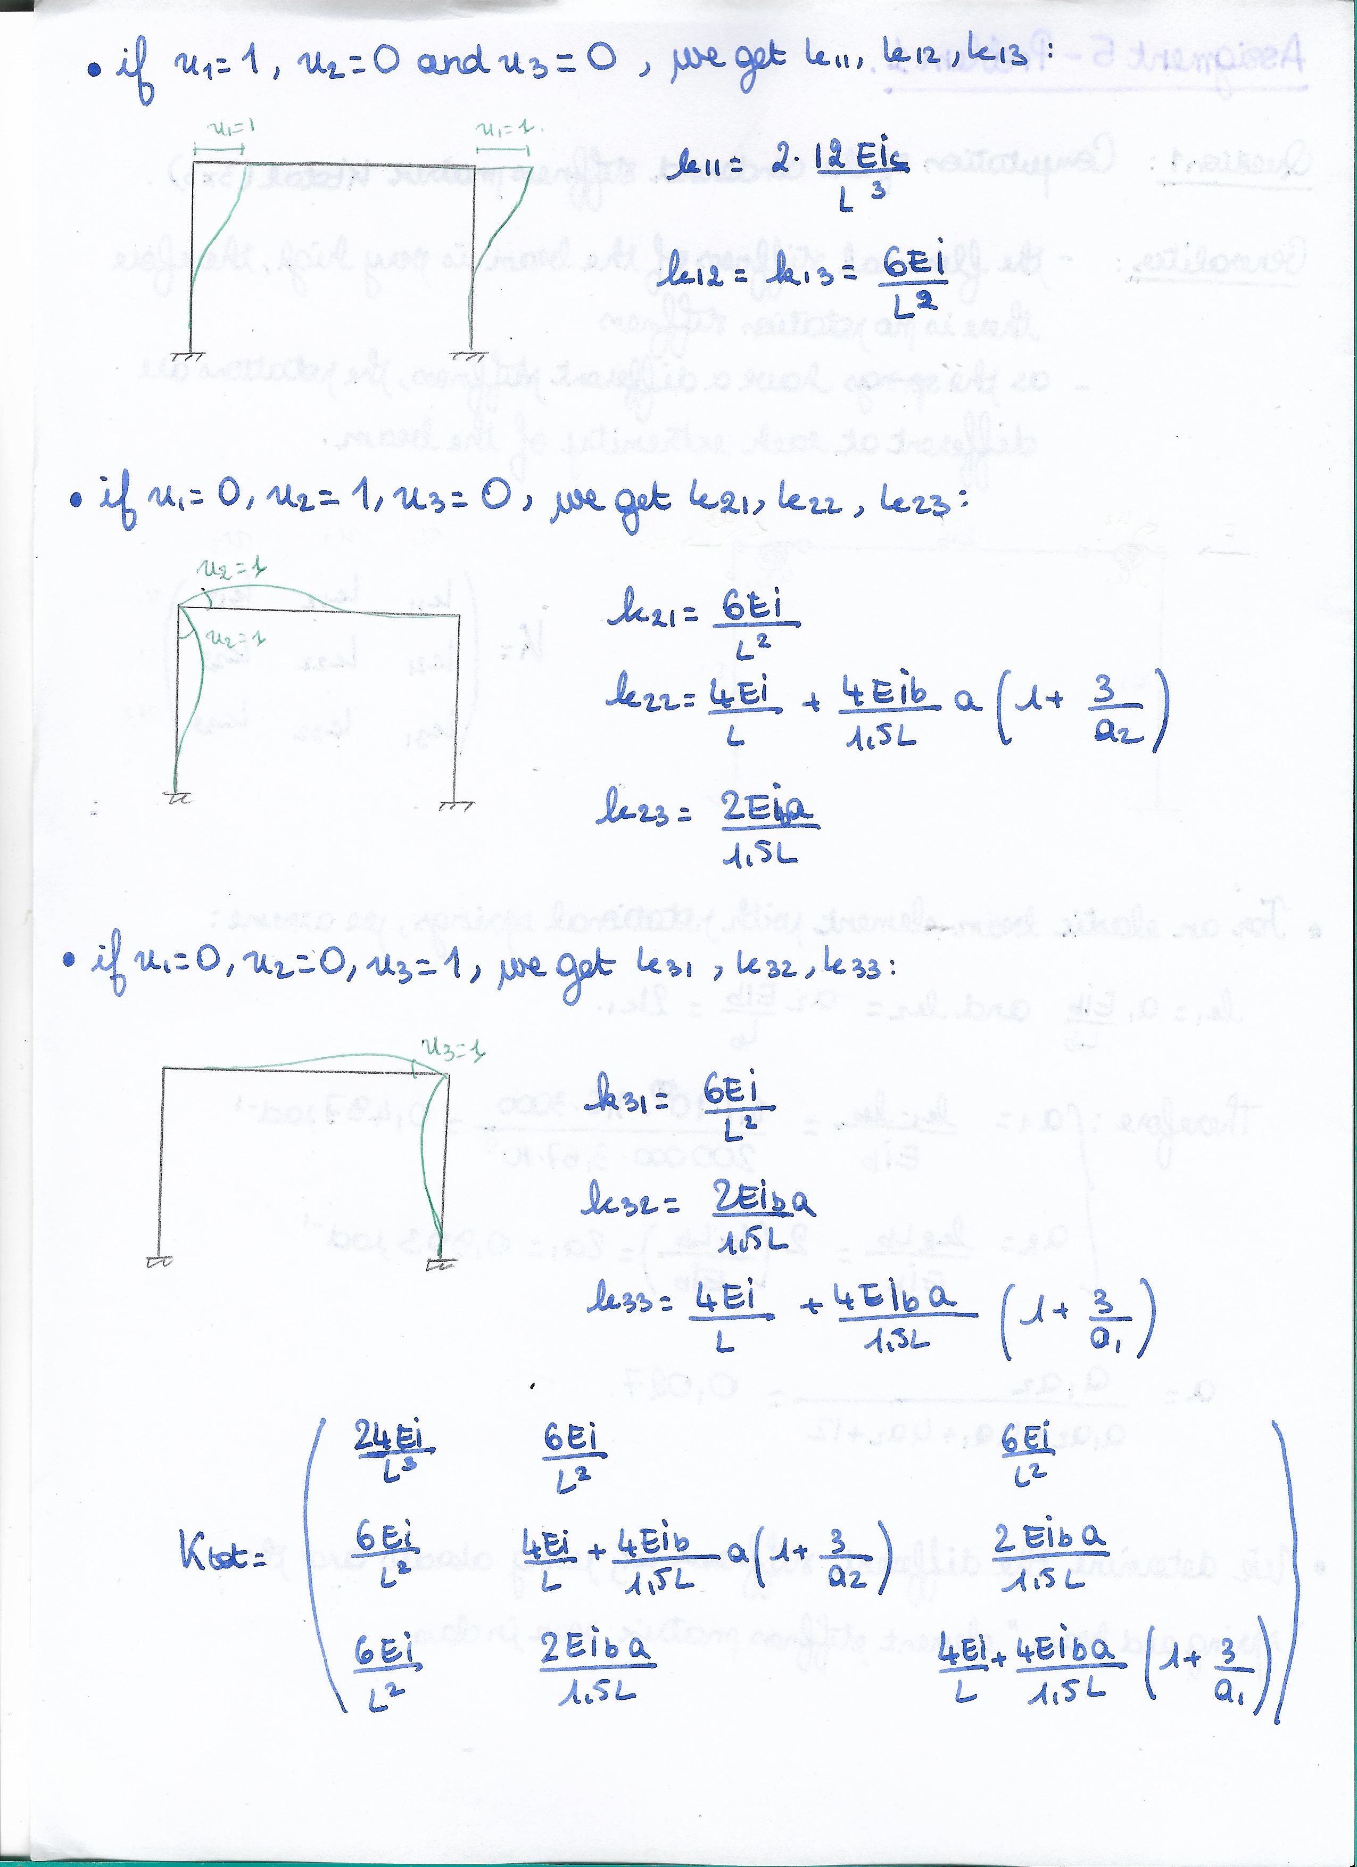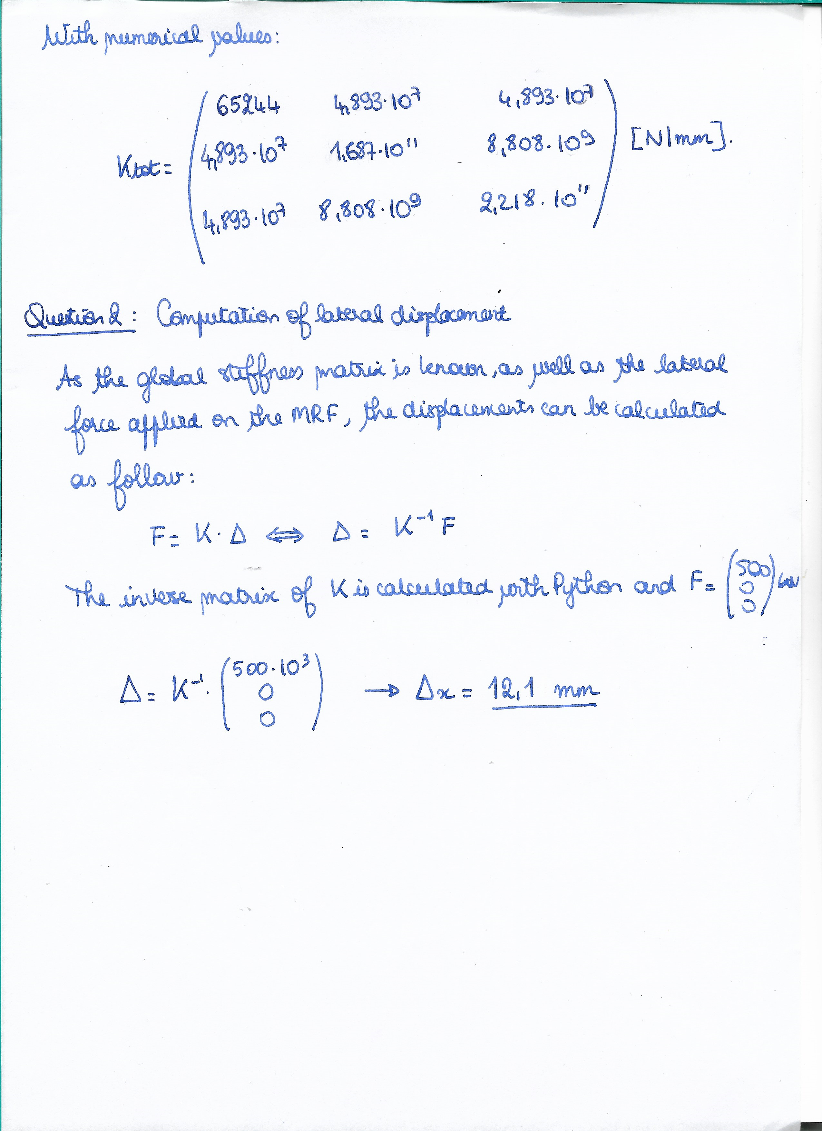

The horizontal displacement is 12.1mm.

3. Verification of the results using OpenSeesNavigator:

The steel MRF had been modelled in OpenSeesNavigator, as shown below:

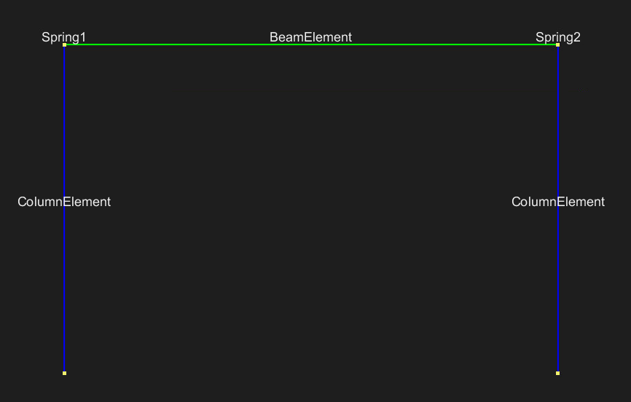

Figure 1: Elements defined in OpenSeesNavigator for the steel MRF

In this problem, as linear geometric transformation are considered, the columns and beam elements are considered elastic (the stresses in the elements are always below the yield limit of the material). The spring are modelled as Zero-Length elastic elements. Their respective stiffnesses have been defined in the software.

Applying a lateral load of 500kN on the frame, a displacement of 12.35mm is obtained.

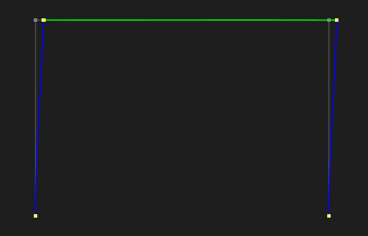

Figure 2: Displacement of the MRF under a lateral load of 500kN (the displacement has been increased by a factor 10)

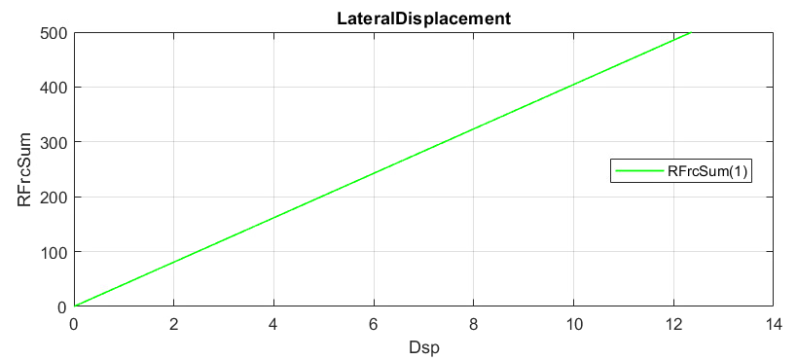

Figure 3: Lateral displacement as a function of the lateral load applied on the MRF

The displacement obtained is: Δ=12.36mm, which is very similar to the displacement calculated by hand calculation (difference of 2.1%).

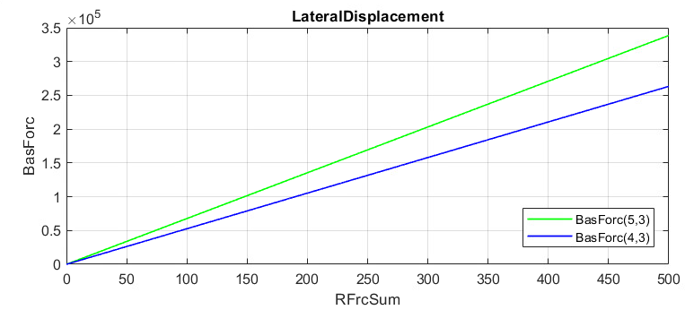

Figure 4: Force inducing bending moments in the springs (blue graph for the left spring and green graph for the right spring)

For a load of 500 kN, the maximum moment obtained in the springs is 263323 kNm for left spring and 338659kNm.

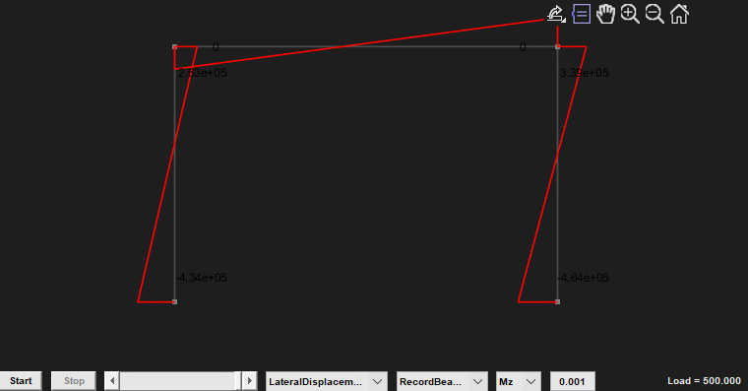

Figure 5: Bending moment diagram in the MR frame

4. For a uniform elastic element, the area and second moment of inertia are constant. Assuming a very large area for the elements enables to ignore possible small changes in the cross-section area of the elements. Moreover, the axial stresses can be ignores as for a very large area, axial stresses would not be predominant.

**Problem 2:**